AI Tool Use & Reflection

Impact on Velocity and Quality
Using AI tools significantly accelerated the development velocity for the Week 8, 13, and 14 labs. For instance, the AI was able to instantly generate the boilerplate code for the React Router implementation (Week 8) and the complex state management required for the Gemini API integration (Week 14). Manually typing out the Material-UI imports and component structures would have taken hours; with AI, the initial prototypes were ready in minutes.

However, this speed came with a trade-off in initial quality regarding project structure. The AI initially generated a nested directory structure (src/labs_w8/.../solution/) that felt artificial and disconnected from the existing codebase. While the code worked, the architecture lacked the "human touch" of a cohesive project. This required a significant refactoring phase to flatten the directories and standardize the UI to use a consistent Tabbed interface across all weeks, demonstrating that AI is excellent for generation but requires human oversight for architectural consistency.

Validation and Avoiding Over-Reliance
To avoid over-reliance, I treated the AI as a junior developer rather than an autopilot. I validated every major step:

Code Review: When the Week 8 tab failed to load, I didn't just ask the AI to "fix it." I investigated the issue and verified that the import paths were incorrect (../../ vs ../), confirming that I understood the underlying file structure.

Build Verification: I consistently ran npm run build to ensure that the AI-generated code didn't introduce type errors or missing dependencies, catching unused imports in Week9.tsx and TestingTools.tsx.

Security: I strictly managed the VITE_GEMINI_API_KEY. Instead of letting the AI hardcode it, I enforced the use of .env files and updated .gitignore to prevent security leaks during deployment.

Conclusion
The AI was a powerful accelerator for writing syntax and logic, particularly for the RAG and Chatbot features. However, the final quality and professional polish renaming the project to "CMPE 280 Labs," restructuring the folders, and ensuring a consistent user experience came from my own direction. I used AI to build the bricks, but I remained the architect of the final application.
Screenshots

Directory Structure: A screenshot of your VS Code file explorer showing the clean src/components/weekX structure (proving you refactored the AI's messy output).
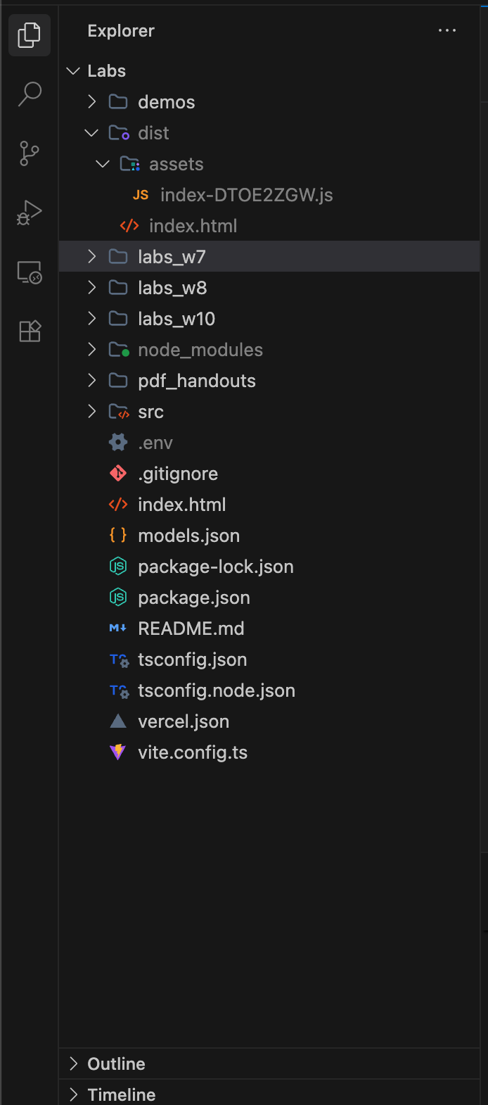

Week 14 Chatbot: A screenshot of the working Chatbot UI with the "Tutor" role selected (demonstrating the complex feature integration).

